A-3
COMMENTARY
A LEARNING FRAMEWORK
A drive to learn
What drives learning:
1 Basic needs – Maslow – 5 levels
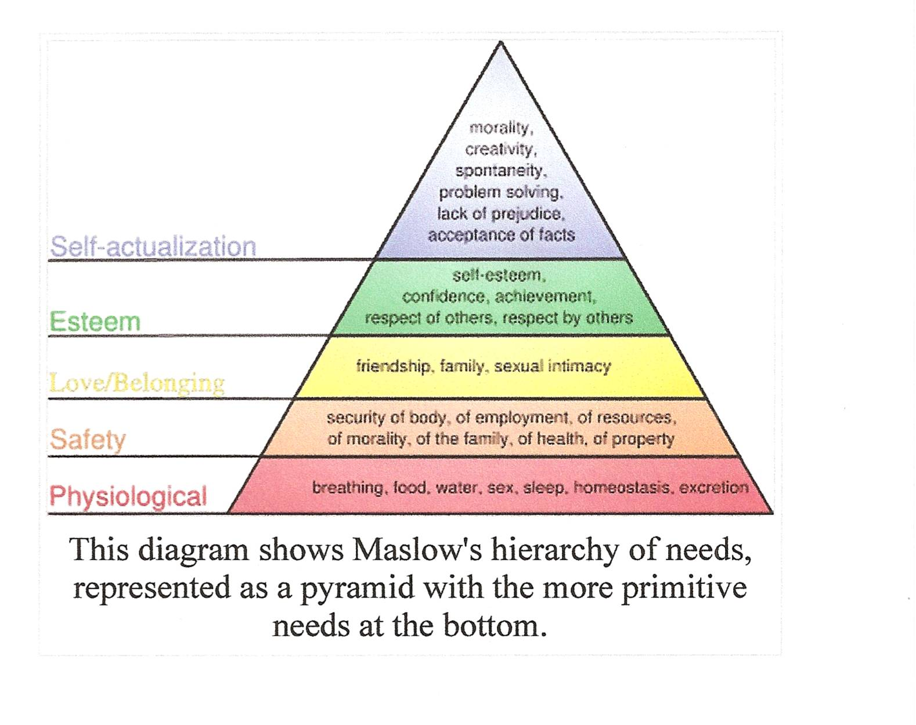

Real or imagined life roles - Oregon
- Individual
- Family Member
- Citizen
- Learner
- Consumer
- Producer

Imagined future:
- Family
- Career
- Lifestyle
- Community
- Income

- Life role - broad pattern or groupings of life’s major activities

